From the Rabbi’s Desk
Rabbi Manes Kogan
Hillcrest Jewish Center

D’var Torah for the Second Morning of Rosh Hashanah
5777
The Gideons International is an Association of Christian business and professional men well known for providing Bibles in hotels rooms, among other activities.
If you have been to a hotel, I assume that you have encountered a Gideon’s Bible, even if you just wanted to see what surprises were in the drawer of the night table.
Being familiar with the work of the Gideons, I was aware that the placing of the Bibles in hotels rooms is part of a bigger plan to preach to non-Christian believers, and consequently, I kept away from these Bibles, which contain not only the Jewish scriptures in a Christian translation but also the New Testament.
One day, however, while staying in a hotel as part of a rabbinic conference, I decided to browse through the Bible, starting from the end (I figured I could go straight to the end of the story.) At the end of the Gideon’s Bible, you will find different verses to be recited or thought about when encountering particular feelings.
Finding forgiveness in times of conviction Read Isaiah 1
Finding protection in times of danger Read Psalms 91
Finding peace in time of turmoil Read Isaiah 26
Finding guidance when making decisions Read Proverbs 3
Finding comfort when you feel lonely and depressed Read Psalms 23
Being away from home, and feeling on that particular day a little lonely, I turned to Psalms 23 and after reading it, I found scribbled at the bottom of the psalm: “if after reading Psalm 23 you still feel lonely, you can call Maribel Escort Services at 809-324-9857.”
To be honest, the story, the way I just shared it with you, never happened. I didn’t explore the Gideon’s Bible, I didn’t find anything scribbled at the bottom of Psalms 23, and I didn’t call any Maribel Escort Services.
However, I do sometimes feel lonely and depressed, if not on that particular day, on a different day, or on different occasions.
Have you ever felt lonely or depressed? If the answer is yes, you are not the only one.
This past year, “clergy across New York City were talking to their flocks about mental health as part of an ambitious education push by Chirlane McCray, Mayor Bill de Blasio’s wife. The campaign was one of Ms. McCray’s largest engagement efforts to promote ThriveNYC, a plan to overhaul the city’s mental health system.”
You probably saw the signs on the bus stops: Depression doesn’t define me! Bipolar Disorder doesn’t define me! and yet, there is a vital need to talk about mental health in our communities because too many people do believe that mental health conditions define them.
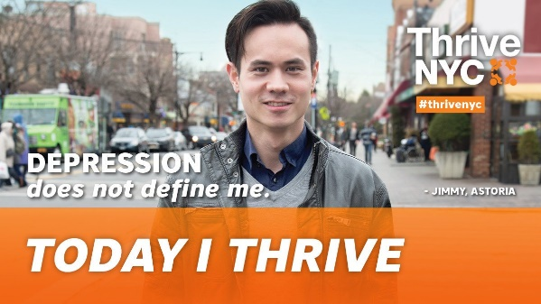
“As a parent, Ms. McCray explained, she was caught off guard when her daughter, Chiara de Blasio, said she had depression and substance-abuse issues. ‘I wished I could just love her, love her into wellness,’ Ms. McCray told those gathered at Convent Avenue Baptist Church, who nodded their heads while saying ‘amen’ and ‘that’s right.’ But she said that her love was not enough.”
Umbrella Jewish organizations in America, like the UJA Federation of New York, are tackling mental health issues in the Jewish community, enlisting Jewish clergy at the top of their list.
Last September 12, I participated at a one-day conference sponsored by the UJA Federation entitled: “What Congregational Leaders Need to Know About Mental Illness.” The conference was geared to clergy and congregational leaders and was relatively well attended, well put together, and both informational and inspirational.
However, I was only one of three or four pulpit rabbis in attendance.
To be honest, I don’t blame my colleagues. With the High Holy Days on the horizon, everybody was busy trying to work on their sermons, and I was not the exception. Now, I have always affirmed that addressing mental health issues in my community was an intrinsic part of my rabbinate. I did talk the talk, but what would it have meant for me to walk the walk?
I decided that in order to make a statement I needed to attend the UJA conference on mental health, even if the timing was far from ideal. The problem was that once I had participated in the conference, it became clear, deep inside, that just attending the conference was not going to be enough walk for me to walk.
So, to come to the point, I decided to walk the walk by talking the talk at a time when I can make a difference and what better time than during the High Holy Days.
Actually, I wanted to invite First Lady Chirlane McCray to join me today, so both of us could address you, but it didn’t work out. I do hope, however, to have her join us at Hillcrest Jewish Center in the future since what First Lady McCray has to share is very powerful. It speaks to me, and I hope it speaks to you as well. She said, “Mental health influences how ably we perform in every part of life – parenting, relationships, school or work, recreation, self-care and all other parts of life.”
“People have to find their own way to healing,” she said. “Sometimes, that’s God anointing a therapist or balancing the chemicals in your body with medication… but first, the public has to be convinced that mental illness exists and that it is acceptable to seek help.”
“Rev. Dominique Chantell Atchison, from Brown Memorial Baptist Church in Brooklyn, said that after Ms. McCray visited her church in March, more than a dozen parishioners approached her for advice about relatives or co-workers with mental illness. ‘It normalized the struggles that some people might have dealt with in their own families,’ Ms. Atchison said.”
Now, how can I normalize the struggles of my congregants when it comes to mental illness? How can I make it “kosher” for Hillcrest Jewish Center families dealing with an anxiety disorder, depression, bi-polar disorder, substance abuse, schizophrenia, autism, panic attacks, and obsessive compulsive disorder, to talk about their pain and suffering without feeling shame? How can I encourage those suffering among us to reach out, or to seek professional help?
Let’s try an exercise....
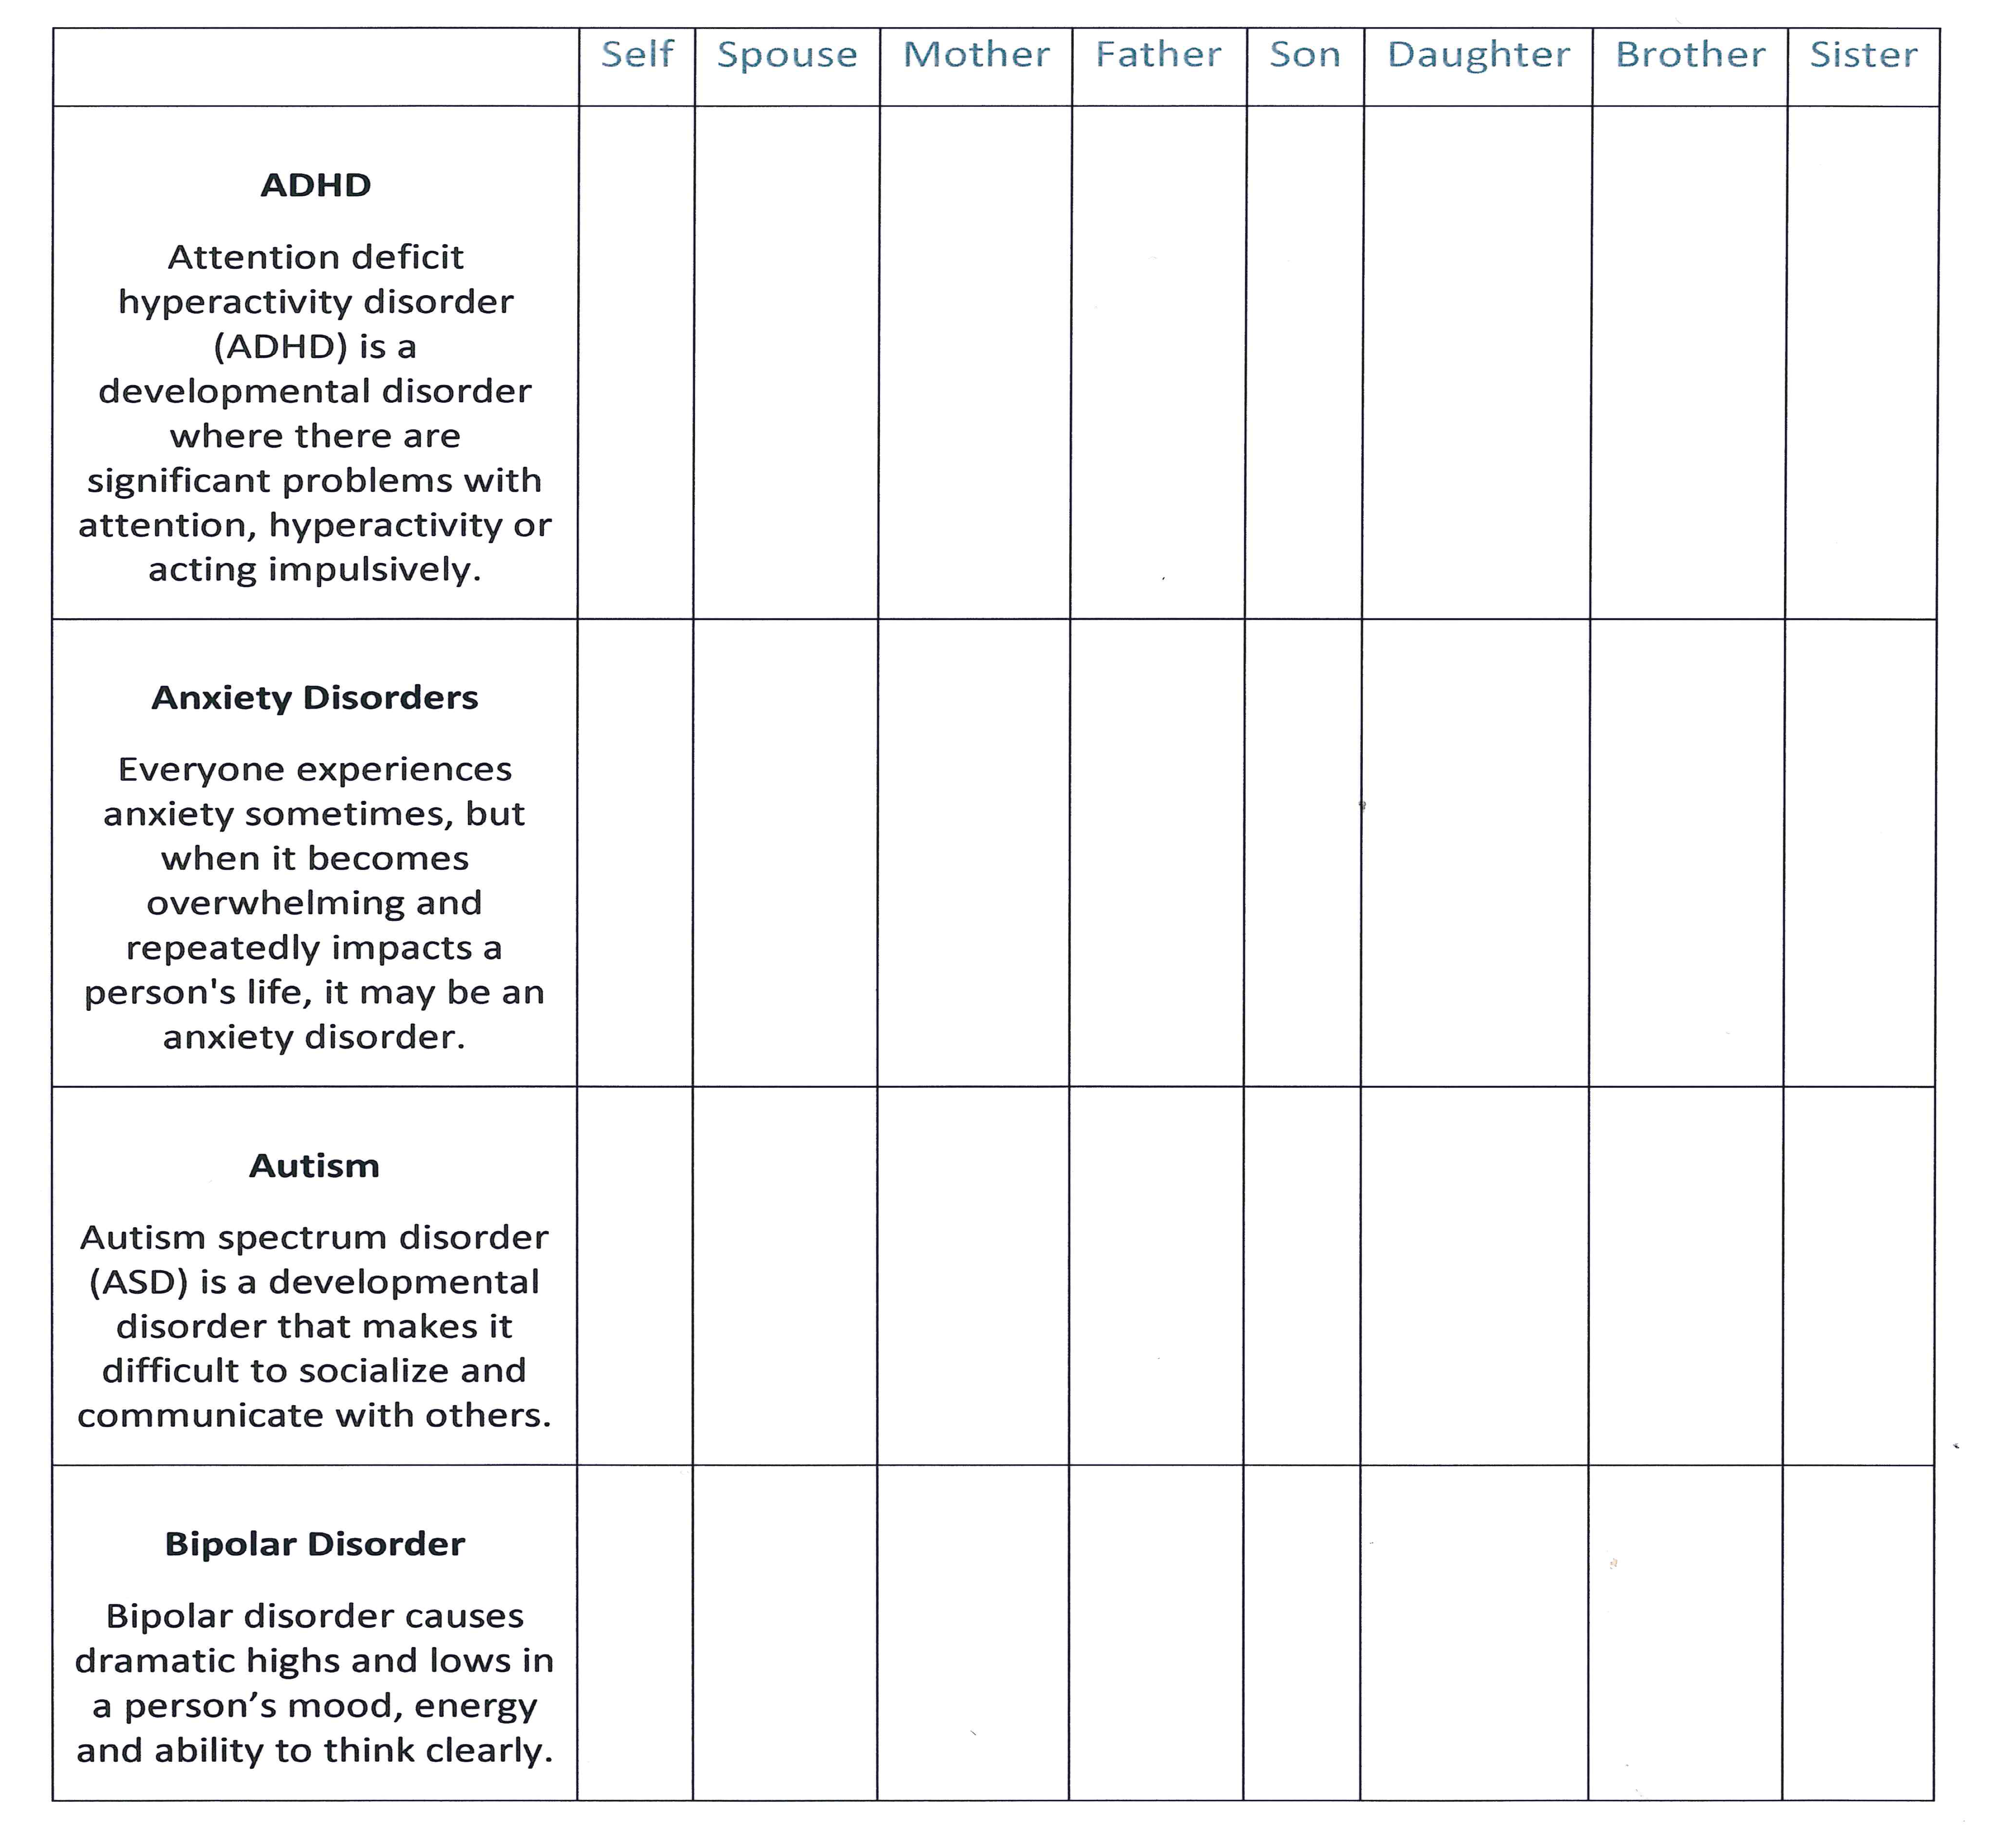
I hope this exercise conveyed the point: mental illness is something that touches most of us, if not all of us. Will this exercise, however, help you to ask for help if you or a loved one is struggling with mental illness? Since I am not sure, I would like to do something else, something more. As you heard me repeat many times: whenever I speak to you, I actually speak to me; whenever I speak about you, I actually speak about me.
Today I wish to share with you that my family and I have struggled and continue to struggle with mental health issues.
As a family and individually we tried to deal with mental health issues in a variety of ways. We tried to deny it, to minimize it, to rename it, to soften it, to bury it under the carpet, to keep it to ourselves, to live an “everything is OK” life, to justify it, to suffer in silence, and to blame God, society, teachers, parents and genes, until we realized that there is one way to deal with mental health issues and that way is to name it, to face it, and to seek help.
Paraphrasing the well-known saying, “God helps those who seek help,” and I would add, God can help even better through those who are trained to offer help and to make a difference.
As a rabbi I am bound by confidentiality and therefore I cannot tell you of the struggles of my congregants who wish to keep their pain and their suffering to themselves. How can I blame them? After all, only a few minutes ago, I spoke to you for the first time about my own struggles after ten years of being your rabbi.
To open myself to you, I confess, is painful. I would rather maintain a perfect image of a flawless rabbi whose only defect is a slight charming accent when he speaks English.
However, a vain attempt to appear issueless won’t help anybody; and I hope, I pray, that my words to you today will make a difference, that this practical dvar Torah will encourage any of you or your loved ones who suffer in silence and loneliness to seek help and support.
As the Rev. Que English, a senior pastor at Bronx Christian Fellowship, said: “mental health issues were on the list of taboo subjects, like AIDS and domestic violence, that her church was now tackling. ‘The old adage, “What goes on in the house stays in the house” has been quite harmful to families and the community at large,’ Ms. English said. ‘The pulpit isn’t simply to discuss chapter and verse but to address issues that plague our parishioners when Monday morning rolls around.’”
The reflections I shared with you today are what I hope will be the beginning of a process of learning about mental health conditions, and an open door policy for anybody who wishes to talk to me about their struggles with mental illness, whether it be their own or their families’. Outside the sanctuary you will find brochures that will help you understand what mental illness is and what it is not, and how to get the help you and your loved ones need and deserve. If you are interested in helping me to increase awareness on mental health issues among Hillcrest Jewish Center members and their families, please talk to me after the holidays. We can work together to make a difference.
Master of the Universe, help us to acknowledge our suffering, to name our pain. Bring down the barriers of shame and awkwardness that prevent us from seeking the help and support we need. Today, on the Day of Judgement, we ask your help to become more embracing, less judgmental, more inclusive.

May this year be one of health, comfort, kindness and compassion. May all of us and our loved ones be blessed with a healthy, peaceful, joyous, and sweet year. Amen.

Mental Health Conditions
A mental illness is a condition that affects a person's thinking, feeling or mood. Such conditions may affect someone's ability to relate to others and function each day. Recovery, including meaningful roles in social life, school and work, is possible, especially when you start treatment early and play a strong role in your own recovery process.
A mental health condition isn’t the result of one event. Research suggests multiple, linking causes. Genetics, environment and lifestyle influence whether someone develops a mental health condition. A stressful job or home life makes some people more susceptible, as do traumatic life events like being the victim of a crime. Biochemical processes and circuits and basic brain structure may play a role, too. In addition to a person's directly experiencing a mental illness, family, friends and communities are also affected.
 | Self | Spouse | Mother | Father | Son | Daughter | Brother | Sister

ADHD
Attention deficit hyperactivity disorder (ADHD) is a developmental disorder where there are significant problems with attention, hyperactivity or acting impulsively.

Anxiety Disorders
Everyone experiences anxiety sometimes, but when it becomes overwhelming and repeatedly impacts a person's life, it may be an anxiety disorder.

Autism
Autism spectrum disorder (ASD) is a developmental disorder that makes it difficult to socialize and communicate with others.

Bipolar Disorder
Bipolar disorder causes dramatic highs and lows in a person’s mood, energy and ability to think clearly.

Borderline Personality Disorder
Borderline personality disorder (BPD) is characterized by severe, unstable mood swings, impulsivity and instability, poor self-image and stormy relationships.

Depression
Depression is more than just feeling sad or going through a rough patch: it’s a serious mental health condition that requires understanding and treatment.

Obsessive-compulsive Disorder
Obsessive-compulsive disorder causes repetitive, unwanted, intrusive thoughts (obsessions) and irrational, excessive urges to do certain actions (compulsions).
Posttraumatic Stress Disorder
PTSD is the result of traumatic events, such as military combat, assault, an accident or a natural disaster.

Schizophrenia
Schizophrenia causes people to lose touch with reality, often in the form of hallucinations, delusions and extremely disordered thinking and behavior.

http://www.nytimes.com/2016/05/23/nyregion/chirlane-mccray-enlists-new-york-clergy-in-mental-health-outreach.html
Ibid.
http://www1.nyc.gov/office-of-the-mayor/news/315-16/mayor-de-blasio-permanently-establishes-mental-health-council
http://www.nytimes.com/2016/05/23/nyregion/chirlane-mccray-enlists-new-york-clergy-in-mental-health-outreach.html
http://www.nytimes.com/2016/05/23/nyregion/chirlane-mccray-enlists-new-york-clergy-in-mental-health-outreach.html
Ibid.

